## SCHOOL OF SCIENCE AND ENGINEERING

**TIMESHEET MANAGEMENT MOBILE APPLICATION FOR ILEM GROUP**

## Internship Report

Submitted in

**Summer 2022**

by

**Mohammed Ait El Qadi**

Supervised by

**Mr. Marouane Bouzoubaa, Microsoft Business Unit Director**

and

## Dr. Driss Kettani, Al Akhawayn University

**Acknowledgment**

My internship at Ilem Group was an outstanding and fruitful experience that shaped me both personally and professionally. This enriching journey would not have been this amazing without the guidance and continuous feedback of my company supervisor, Mr. Marouane Bouzoubaa. Thank you for your time, for your understanding and for all the mentorship that you provided me during this internship period. I would also like to thank all the employees and the family of Ilem Group who were very welcoming and helpful. Thank you, Ziad El Khomssi, for providing me with any information I needed during my internship.

I would like to express my gratitude to Dr. Driss Kettani for accepting to supervise me academically for both my capstone and internship, and especially for mentoring me and introducing me to the field of Software Engineering. Thank you for all the support, guidance, and knowledge you provided me with throughout my whole journey at Al Akhawayn University.

Finally, I would like to thank my beloved parents and family for their continuous help, support, and love.

**Abstract in English**

The aim behind this report is to explain and detail the work I was assigned to do at Ilem Group, which is an IT outsourcing company located in Casablanca. My internship period started on the 16th of May and ended on the 20th of July. During this period, I was working on the development of a mobile application that will take care of the management of timesheets for external employees.

The mobile application will make the process of invoicing at the end of the month easier for the accounts payable department, it will make it much easier for the external employees to submit their monthly report and it will help overcome the difficulties presented by the existing system. The tasks I carried out for the realization of this project were requirements engineering, the design phase, development, and testing.

This internship experience allowed me to learn, explore, and apply many skills that I learned at the university.

**Abstract in French**

L'objectif de ce rapport est d’illustrer et élucider le travail qui m'a été confié au sein de Ilem Group, une société d'infogérance informatique située à Casablanca, qui m’a accueilli pour une période allant du 16 mai et jusqu'au 20 juillet. Une période dans laquelle j’ai travaillé sur le développement d'une application mobile chargée de la gestion du TimeSheet des employés externes.

L'application mobile facilitera le processus de facturation à la fin du mois pour le service des comptes fournisseurs, il sera beaucoup plus facile pour les employés externes de soumettre leur rapport mensuel et elle aidera à surmonter les difficultés présentées par le système existant. Dans ce cadre, les tâches que j'ai effectuées pour la réalisation de ce projet étaient l'ingénierie des exigences, la phase de conception, le développement et les tests.

Cette engageante expérience de stage m'a permis de mettre en pratique mes acquis universitaires ainsi que les parfaire.

**List of Acronyms and Abbreviations**

* **CSS:** Cascading Style Sheets
* **APP:** Application
* **RNN:** React Native Navigation
* **RN:** React Native
* **IT:** Information Technology
* **ERP:** Enterprise Resource Planning
* **API:** Application Programming Interface
* **Auth:** Authentication
* **CPM:** Conceptual Process Model
* **JWT:** JSON Web Token
* **REST:** Representational State Transfer
* **JSON:** JavaScript Object Notation

**List of Figures**

**Figure 01:** The software development Life cycle

**Figure 02:** Incremental Model

**Figure 03:** JavaScript

**Figure 04:** React Native

**Figure 05:** Tailwind CSS

**Figure 06:** RN-Navigation

**Figure 07:** RN-Elements

**Figure 08:** Redux

**Figure 09:** EXPO

**Figure 10:** Node.js

**Figure 11:** REST API

**Figure 12:** JWT

**Figure 13:** System Architecture

**Figure 14 :** Conceptual Architecture

**Figure 15 :** CPM

**List of Tables:**

**Table 01:** Internship Management Plan

**Table 02:** CPM Description

**Table of Content**

Acknowledgement 2

Abstract in English…. 3

Abstract in French……...... 4

List of Acronyms and Abbreviations 5

List of Figures 6

List of Tables 6

Table of Content... 7

1. Internship Background 8
   1. Description of the company 8
   2. Work attributed 9
   3. Reasons for choosing the internship 9
2. Internship Plan 10
   1. Project Methodology………... 10
   2. Software Engineering Process Model………... 10
   3. Internship Management Plan... 12
3. Internship Results 13
   1. Requirement Specification 13
      1. Functional Requirements. 13
      2. Non-functional Requirements...... 13
      3. Business Rules.... 14
   2. Project Design 15
      1. Technology Enablers....... 15
      2. System Architecture.... 18
      3. Conceptual Architecture 19
      4. Conceptual Process Model 21
   3. Project Implementation. 23
4. Lessons Learned. 29
5. Conclusion in English 30
6. Conclusion in French 31

References 32

1. **Internship Background**
   1. **Description of the company**
      1. **Type of Company:**

Ilem Group is composed of 5 subsidiaries in Switzerland, France, and Morocco, specializes in the management, implementation, and optimization of the information systems of the companies of any size.

* + 1. **Origin:**

Ilem Group was founded to carry out IT projects. The opportunity to outsource the IT department of Migros cooperatives led to the beginning of the Ilem journey in 2001. It has been able to tackle the obstacles of creating an independent and autonomous firm thanks to the skills, dynamism, and dedication of the team.

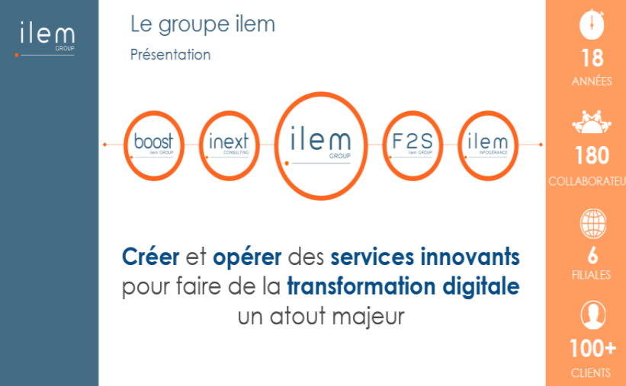

* + 1. **Field of Expertise:**

Thanks to the competences of the team members, the company has expertise in different fields, such as infrastructure management, Cloud Infrastructure, Security, development of applications…

The company has different objectives and adopts a “mixed” model: on the first hand the realization of projects for third parties and on the other hand the realization of internal projects aiming the production of original software solutions dedicated to specific needs.

* + 1. **Values:**
* Know-how and know how to be: the foundations of cooperation are active listening and a sense of unity.
* Technological and human innovation: offer cutting-edge solutions that are tailored to the everyday experiences of people.
* Customer and employee satisfaction
* Quality: giving meaning and well-being at work

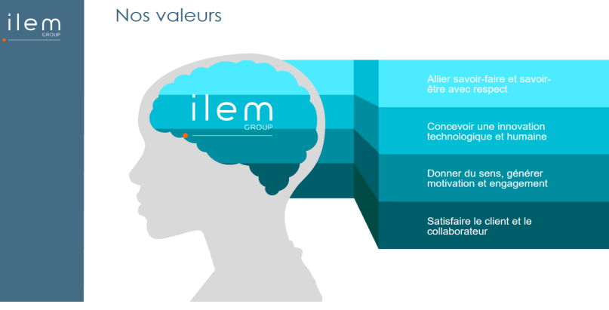

* 1. **Work attributed**

Nowadays, with the availability of all the new technologies on the market, all the organizations are putting huge effort to familiarize and make use of these new improvements in order to adapt and keep up with the computer science field development. ILEM group decided to profit from the new technologies provided in the field of mobile applications to digitalize all the processes such as ERP (Enterprise Resource Planning) and to transmit to be a mobile enterprise.

I was provided with two different projects to work on, and I decided to work on this project and to be an intern at this company because I figured out that I will be learning many things from this company in the field of IT and this internship will allow me to put my development, critical thinking, and problem-solving skills into test. I am assigned the task of developing a modern mobile application for managing the employees’ timesheets, and I believe that this task is a real-life challenge that will allow me to practice my software engineering knowledge in a professional environment.

* 1. **Reasons for choosing the internship**

Internship is an important opportunity to put into test all the acquired soft and technical skills that we acquired during the undergraduate studies. As a matter of fact, the professional workplace is very different from studies and the learning environment, that is why this internship is an important phase in my life because it is preparing me for the professional world. For these reasons, I chose to do my summer internship at ILEM group in Casablanca in Morocco.

1. **Internship Plan**
   1. **Project Methodology**

Our timesheet management application is a software product, and as we studied in software engineering course, our project had to go through the software life cycle. The software development cycle is defined as the set of generic steps that begin with the requirements engineering and ends with the death of the product (decommission). The main steps of this cyclic process are Requirements specification, Analysis, Design, Implementation, Testing and Maintenance.

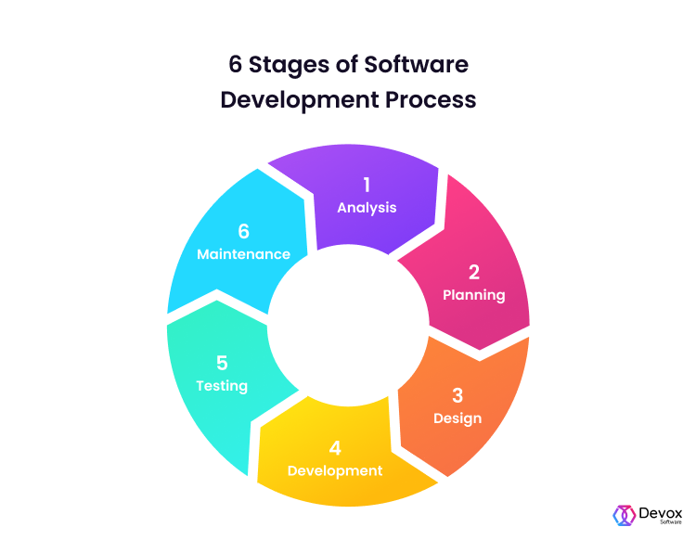

**Figure 01: Software Development Life Cycle**

* 1. **Software Engineering Process Model**

The software engineering process model that I chose for my internship project is the Incremental model. After learning about the idea of the project, I had to analyze the existing web application and well understand the existing business rules and the problem that our mobile application will be solving.

The initial part of the process is requirement engineering, in which we identify, understand, and validate the client’s functional and non-functional requirements. This step is critical in the Incremental model because it turns the needs that are communicated in simple words into functionalities that can be implemented. With the help of my company’s supervisor and after analyzing the handbook of the existing application and several meetings, we were able to identify the needs, the constraints and get a detailed high-level understanding of the project’s requirements.

After defining the requirements, we moved to the design level. At this stage, we used our understanding of the previous stages to come up with a technical solution to the company’s needs. During this phase, we identified the system architecture of our mobile application, the conceptual data model and the conceptual process model that represents the main processes of our system.

After completing the design phase and identifying the best technology stack, the implementation phase starts. During this step, based on the previous results and business rules, I started writing the code for our product.

All along the implementation, the testing stage was taking place. The testing phase is critical in the software engineering life cycle because it is important to conduct a comprehensive testing to release a product that respects all the requirements.

The last important phase is the maintenance. Once the mobile application is released for the employees, there will be for sure the maintenance team that will be taking care of fixing errors that might occur. Also, there will be updates with new features and simplifications.

The main reasons why I chose the Incremental Model:

* The requirements are superior
* The internship period is only eight weeks, and my supervisor demands a quick release of the product
* I focus on developing prioritized requirements first, so that the company gets important functionality first.
* Easy to recognize errors, test, and debug.
* Very flexible and the best compromise between Waterfall and Prototyping models.

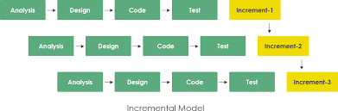

**Figure 02: Incremental Model**

* 1. **Internship Management Plan**

|  |  |
| --- | --- |
| Week | Work Done |
| 1 & 2 | * **Understanding existing ERP** * **Requirement Gathering and Analysis** |
| 3 | * **Setting up the Development Environment** |
| 4 | * **Technology Stack benchmarking** * **Design Phase** |
| 5 & 6 | * **Implementation Phase** |
| 7 | * **Testing Phase** |
| 8 | * **Delivery** |

**Table 01: Internship Management Plan**

1. **Internship Results**
   1. **Requirement Specification**
      1. **Functional Requirements**

* Email/Password Authentication:
  + External employees should be able to log in to the application using their credentials provided by the company (Email Address and Password)
* Sign Out:
  + If the external user is already logged in, he/she shall be able to log off from the application.
* View Profile:
  + The authenticated user should be able to view their profile information.
* Month selection is manual and automatic:
  + The month is automatically suggested based on the not-reported month, or the user can manually choose the month.
* Add Activity reports:
  + The external user will be able to add the activity that he/she was carrying for the month.
* View Activity reports:
  + The external employee should be able to view the last 50 entries of weekly activity reports.
* View the status of last entries:
  + The user will be able to view the status of the last monthly activity reports.
* Choose Project Category and activity type:
  + The employee will have to specify the project category, the project, and the activity of the chosen month.
* Add Absences
  + The external employee should be able to choose manually their absence dates of the chosen month.
* View last absences
  + The employees are able to view their last absences of the current year
* Choose Absence Reason
  + Before submitting, the external employee will have to specify the absence reason.
* Submit
  + After adding the monthly absences and activity, the user will be able to submit the monthly activity report
    1. **Non-functional Requirements**
       - Performance:

The application will be responsive and will guarantee a good performance. The use of latest technologies like Redux will make it possible for the application to get quick responses from the web services, store them and make use of them when needed, which will result in an optimized loading time.

* + - * Security:

Security is the most important requirement for this mobile application because our app will be using sensitive data that will be fetched from the webservices. Therefore, our application will be fully secured by diving it into two parts and using JWT that will make sure that all the app data is secured and protected from outside environment.

* + - * Scalability:

The application should be able to keep functioning in peak hours under lot of loads and be able to handle more data as time progress.

* + - * Useability:

The application should provide a great user experience and be easy to use. The user will not need any guideline to understand the flow of the app.

* + 1. **Business Rules**
       - Each user can sign in using their credentials provided by the company.
       - Each user can keep track of their past absences.
       - Each user is provided with automatically filled in entry fields to make the process quick.
       - Each user is able to manually fill in the entry fields.
       - Each user can add one or more monthly activity reports.
       - Each monthly activity report can be made by one and only one user.
       - Each user can stop the process at any time and data will not be lost
       - Each new user without any past entry will not be able to see any past data.
       - Each user who entered the application in the middle of the month, will only need to choose the absences dates and the rest will be automatically filled with the past activity.
       - Each user will not be able to choose weekends as absence dates.
       - Each user can view the past fifty weekly activity reports.
       - Each user will not be able to modify the already filled absences.
       - Each user will not be able to submit the monthly report until the end of the month
  1. **Project Design**
     1. **Technology Enablers**

One of the requirements is to develop a mobile application that will be able to work on both platforms IOS and Android. Therefore, I decided to develop a cross-platform application that is able to function on multiple platforms. For the application to be present on both Google Play Stope and Apple Store, I opted for React-Native framework for the development of cross-platform application. Since the application will be used by the company and its employees, our mobile app will be getting data from the company’s database by using web-services.

I will divide the technology enables into two categories: Front-end and Back-end.

* Front-End:
  + JavaScript:

I opted for using JavaScript as the programming language for this whole project because it is the main programming language used by React-native framework and other frameworks used in the project. It is the most famous client-side language that is used for the development of dynamic and interactive web applications and light-weight games.

**Figure 03: JavaScript Logo**

* + React-Native:

React-native is an open-source JavaScript framework developed by Facebook in 2015 to be the most famous framework for the development of cross-platform applications that can run on multiple platform such as IOS, Android, and Web by using the same code source. The reason why I opted for using react-native for this project is because it provides many advantages such as real-time synchronization which allows me to see changes that I make in my code at the same time in my screen.

**Figure 04: React Native Logo**

* + Tailwind CSS:

It is a utility-based CSS framework. The difference between Tailwind and other frameworks, is that tailwind provide custom design, focuses on how the item being styles should be displayed and prevents writing long lines of code.

**Figure 05: Tailwind CSS logo**

* + React-Native-Date-Picker:

It is another JavaScript that is used in our project as a datetime picker. It includes many picker modes like date, time, and datetime, but I used date picker mode to get the date to the absent day.

* + React-Native-Calendars:

It is a collection of customizable react native calendar components. This package provides three pre-defined components that are Calendar, Calendar List, and Agenda. The component that I used is Calendar, it is used to accept date and time inputs. The reason why I used this package is to display the user’s absences.

* + React-Native-Navigation:

RNN is the most important module to be used with React-Native. It is built with JavaScript, and it is the component that makes the navigation between screens possible.

RNN has three pre-defined navigators which are stack navigator, tab navigator, and drawer navigator. For my case, I used nested navigators which is a combination of stack navigator and drawer navigator.

RNN takes care of the navigation history and the display of the right screen.

**Figure 06: RN-Navigation Logo**

* + React-Native-Elements:

React-Native-Elements is another very important library. As a matter of fact, it is very hard to develop an application with RN without the use of this library, because it provides you with a set of reusable components for developing your cross-platform application. It provides you with pre-defined components. Instead of writing the whole code of a placeholder or a button, you are provided with pre-defined elements.

**Figure 07: RN-Elements Logo**

* + Redux:

Redux is a state management library that store and manage the state of the application by using a global object that is called Store. I used Redux in my application to store the information contained in JWT and keep the state of my application synchronized.

**Figure 08: Redux Logo**

* + EXPO

Expo is the framework that makes the development of react-native applications possible since it takes care of the build, deployment, and the iteration between the different platforms using the same JS code base.

**Figure 09: EXPO logo**

* Back-End:
  + JavaScript

JavaScript is also used in the Back-End side because we are using Node.js in our project.

* + Node.js

Node.js can be defined as an open-source, cross-platform, JavaScript runtime environment. In our application, Node.js serves as the communication enabler with servers for exchanging data. Also, it allows the built of scalable applications and to run JavaScript outside of a web browser.

**Figure 10: Node.js Logo**

* + REST API

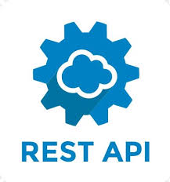REST API cam be defined as an application programming interface that uses HTTP requests to access and use data. Also known as RESTful web service is based on an architectural style to communications often used in Web services development.

RESTful API is the main interface that I am using in my application to communicate and exchange data securely with the company’s database.

**Figure 11: REST API logo**

* + JSON Web Token

JWT is the most secure way that we opted for transmitting information as JSON object. We used JWT for the authentication and authorization. Once the user is logged in, a JWT is created which will allow the user to access services and other resources. Without the token, no one will be able to access the application stack, nor to access web services.

**Figure 12: JWT logo**

* + 1. **Use Case Diagram**

The following is Use case diagram of our system that is used for visualizing the functional requirements of our app that will translate into design choices and development priorities. It identifies any internal or external factors that may influence the system and should be taken into consideration.

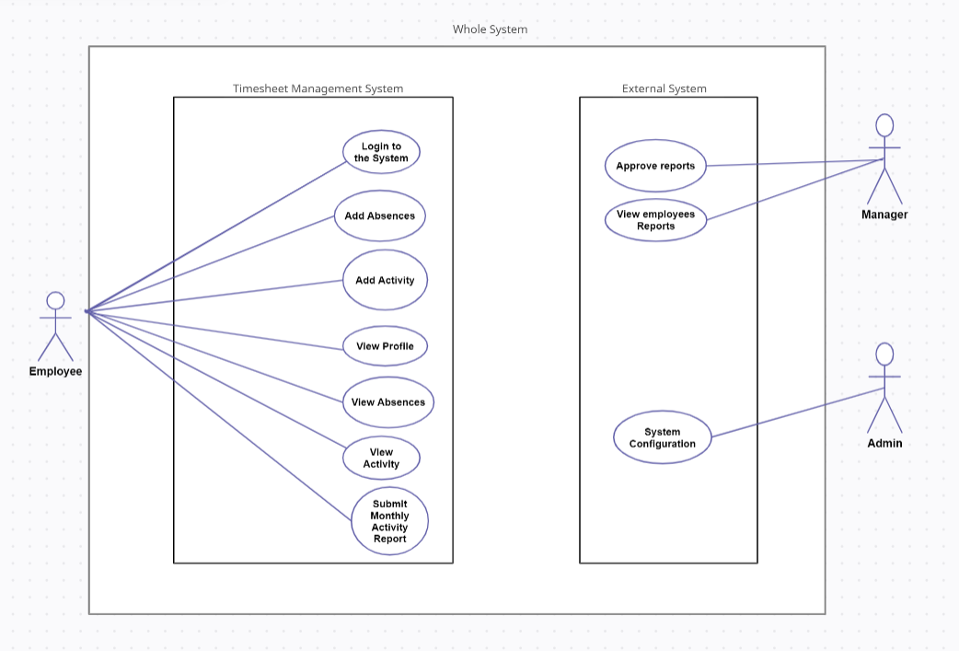

**Figure: Use Case Diagram**

* + 1. **System Architecture**

A system architecture is the conceptual model that represents the main component of our system and how they interact with each other. It demonstrates the structure and the behavior of our system.

In the case of our project, we are fetching data from the company’s database using RESTful API requests. Whenever data is needed, the user interface calls an API endpoint. Afterwards, the data is fetched and returned to the client side as a JSON format that can be used by the User Interface.

The different API endpoints that I used are:

* Authentication Verification
* Get a collaborator data by email
* Get a Collaborator Allocations by Email, Starting date, and ending date.
* Get a Collaborator Absences by Email, Starting date, and ending date.
* Get a Collaborator weekly entries Email, Starting date, and ending date.
* Get Project Category by Email
* Get Project by Project Category ID
* Get activity by Project ID
* 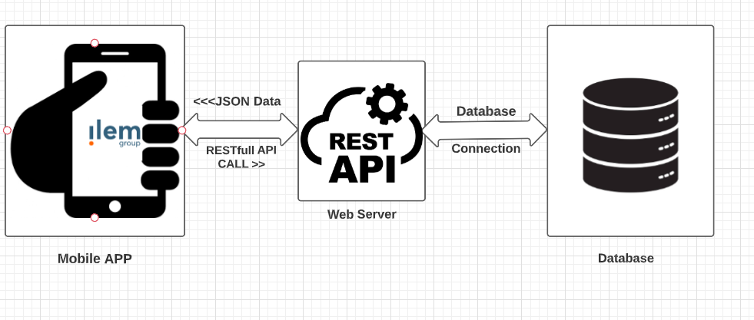Post Allocation

**Figure 13: System Architecture**

* + 1. **Conceptual Architecture**

The conceptual architecture provides with a high-level understanding of the system structure. As you can see below, following a top-down approach, our timesheet management application consists of three building blocks that are going to help us get the Ready for Automation Actions:

* Authenticate Users
  + Sign In / Sign Out
  + View profile info
  + View past absences
  + View last entries
* Add Absences
  + Select manually/suggested month
  + Select absence date
  + Select absence reason
  + Confirm Absences
  + View Added Absences on the Calendar
* Add Activity
  + Select Project Category
  + Select project
  + Select activity
  + Confirm activity
* Add Monthly Activity Report
  + Confirm Activity Report

**Figure 14: Conceptual Architecture**

* + 1. 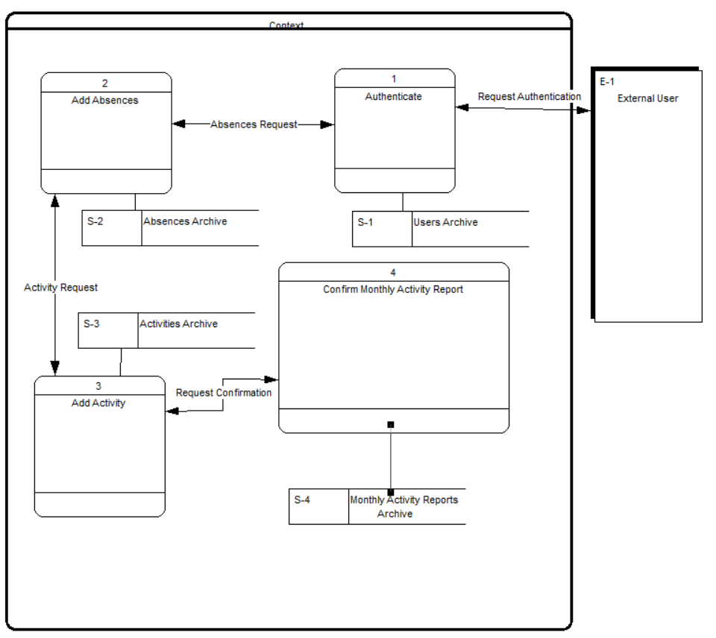**Conceptual Process Model**

**Figure 15: CPM**

The following table provides the description of each process in our CPM:

|  |  |
| --- | --- |
| Process | Description |
| Authenticate | After the launch of our mobile application, the external user will be requested to authenticate using their credentials provided by the company. |
| Add Absences | If authenticated, the user can select the suggested month, or choose the month manually. Then, the user will be able to specify all the dates when he/she was absent, specify the reason for the absence, add a comment, and submit the absences. |
| Add Activity | If authenticated and the absences are already filled, the user is requested the specify the activity that he was carrying for the whole month. |
| Confirm Monthly Activity Report | After completing both the absences and the monthly activity, the user can go back to check the filled information or confirm the Monthly activity report and go back to home screen. |

**Table 02: CPM Description**

* 1. **Project Implementation:**
* **Onboarding Screen & Authentication Screen**

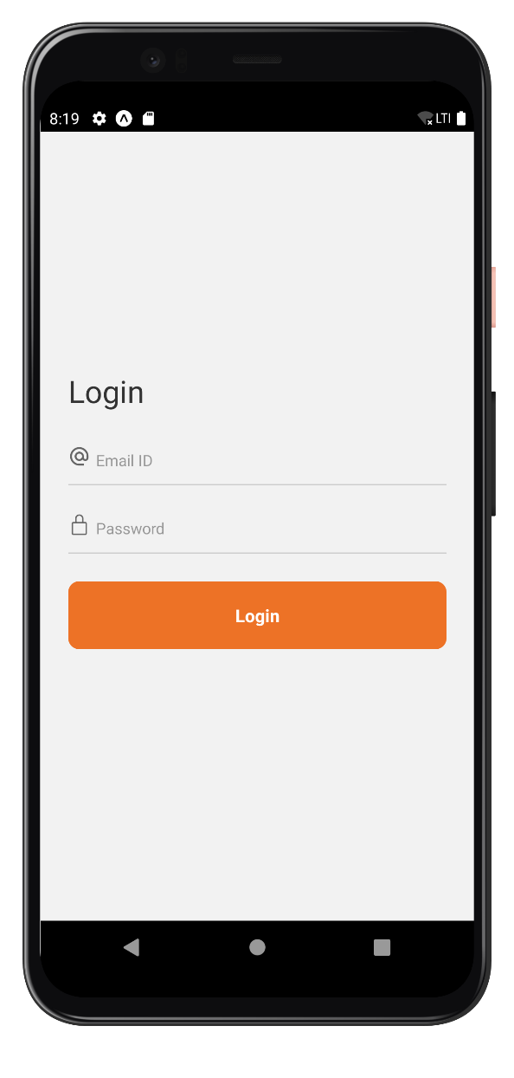

Once the application is launched, the user will be provided with the onboarding screen that shows that this application is part of the Ilem group ERP. After clicking on the Let’s Begin button, the user will be directed to the authentication screen. In this screen, the user enters their credentials, and thanks to Authentication web service, the application will check if the credentials are right, and return a JSON web token to access the application stack if authenticated successfully.

* **Home Screen:**

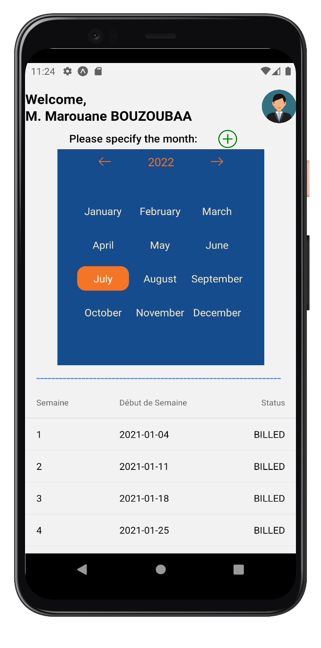

Once authenticated, the user will be directed to the home screen. In this screen, the user is provided with a calendar in order to choose the month manually, or just complete the process with the automatically chosen month.

Moreover, the user is able to view the last fifty activity entries.

After choosing the month, the user can click in the plus button to move to the next screen.

* Une image contenant texte, équipement électronique, ipod, capture d’écran

  Description générée automatiquementUne image contenant texte, capture d’écran, équipement électronique

  Description générée automatiquement**Drawer Navigation and Profile Screen**

By clicking on the profile picture on the top right of the screen, a navigation drawer opens. In the drawer, the user can sign out from the application, stay in the home screen, or open the Profile Screen. By clicking on the profile button, the user is directed to the profile screen where he/she is able to view their personal information.

* 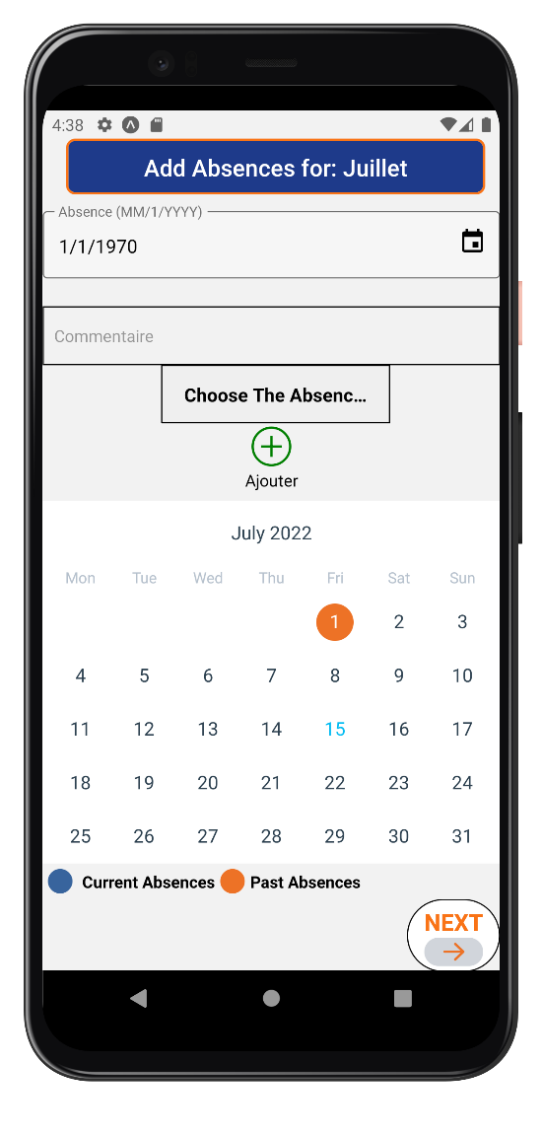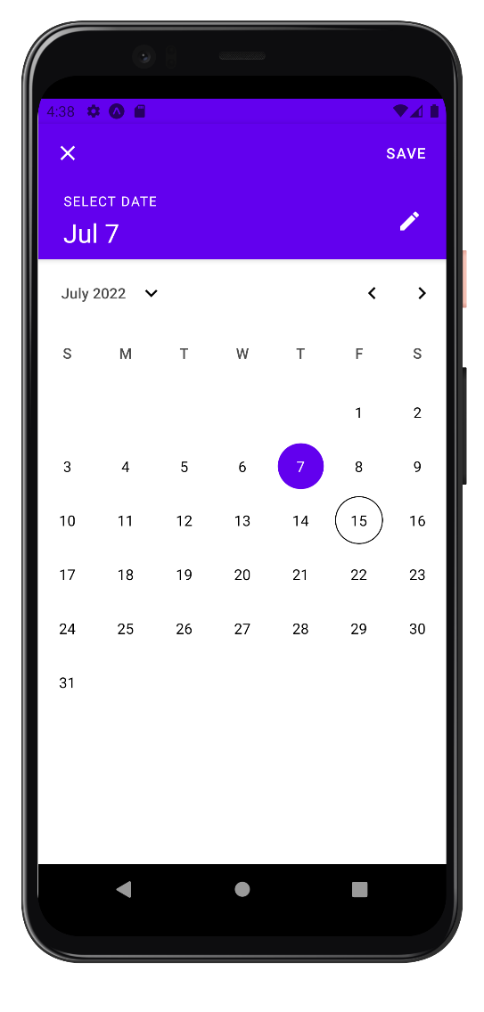**Add Absences Screens**

After choosing the month and clicking on the plus sign, the user will be directed to the absences screen. The user will have first to choose the absent day by clicking on the calendar or by writing it manually. On the bottom calendar, the user is able to view the past and already filled absences.

* 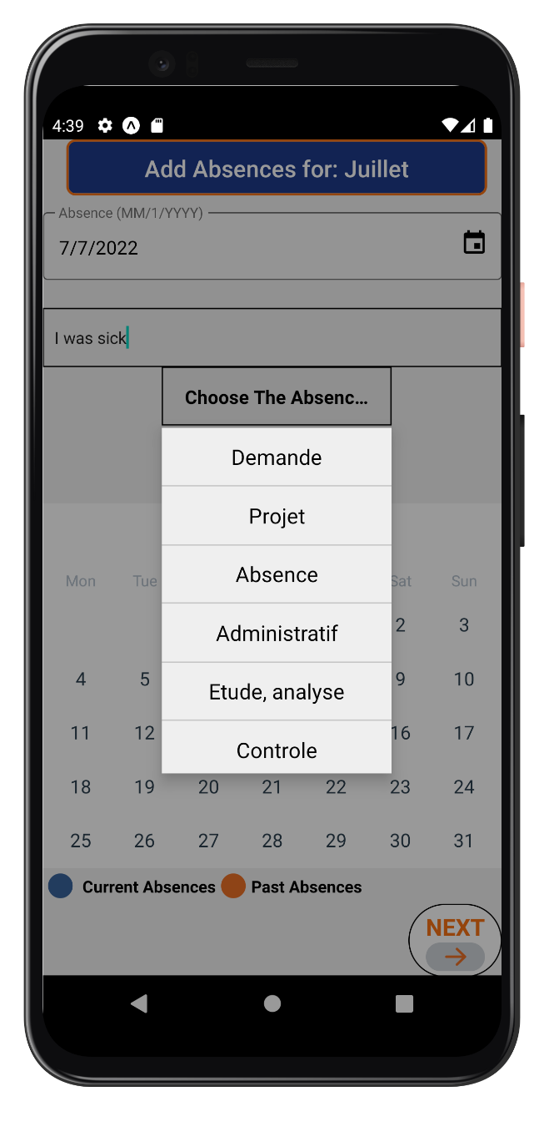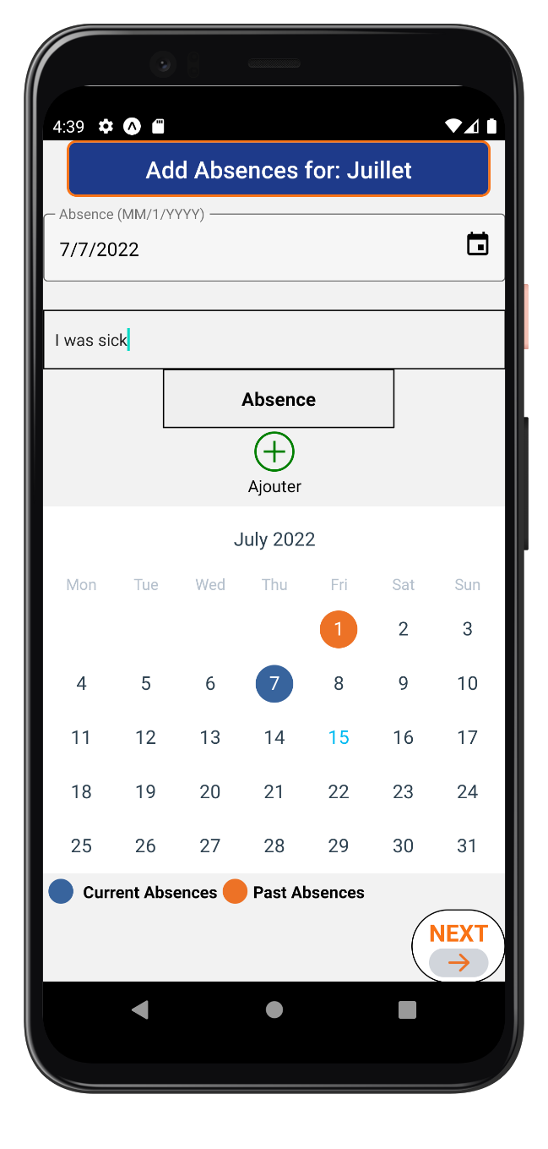**Add Absences Screens:**

After selecting the absent date, the user will have the option to write a comment to explain the absence, and it is mandatory for him/her to choose the absence reason.

After specifying all the needed data for the absence, then the user is ready to click on the plus sign. Automatically, the user will be able to see the current absences that he he/she just filled on the bottom calendar marked in blue.

After finishing the process of adding the absence, the user then is able to click on Next to be forwarded to the next step which is Add Activity.

* **Add Activity Screen**

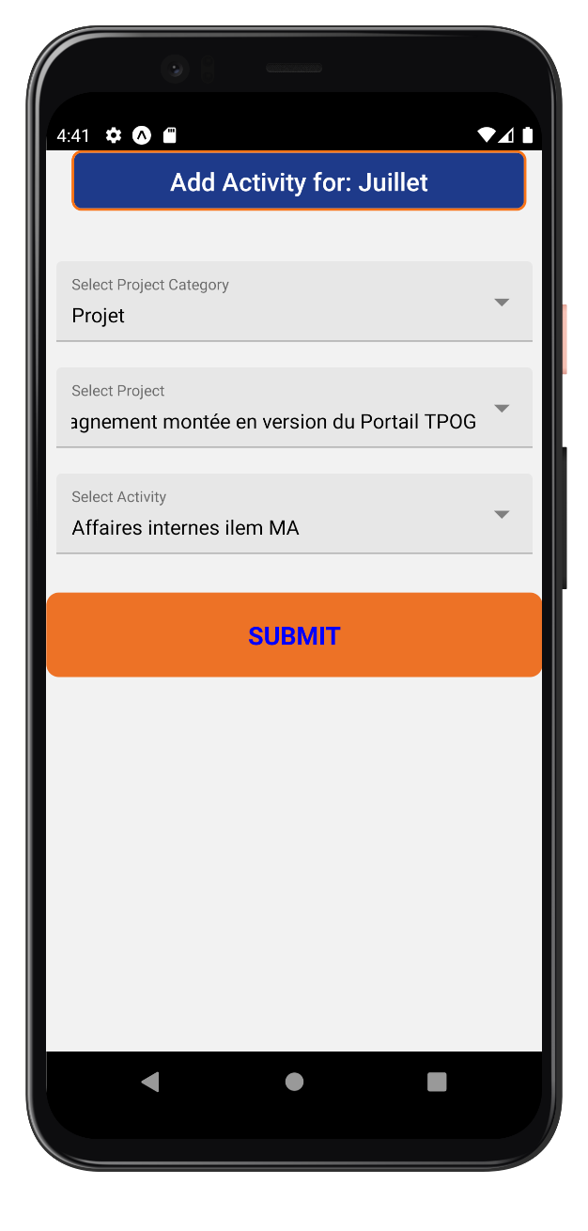

After specifying the absences, the user is then directed to this screen to add the monthly activity. The user is requested to selected project category, the project, and the activity from the drop-down options. After choosing the activity that he/she was carrying for the whole month, the user will be able to submit the monthly activity report. Once submitted the user will be directed to the home screen.

1. **Lessons Learned**

* **Technical Skills:**

I have learned many technical skills during this internship such as:

* + I learned more about REST architecture
  + I learned how to use Web services
  + I learned how to create an API
  + I learned how to use JSON files to transmit data between different applications.
  + I learned about the JWT and Oauth
  + I learned about new JavaScript frameworks that are highly requested in the professional workplace.
  + I learned how to make the application more secure by dividing it into two stacks: the auth stack and the application stack.
* **Soft Skills**

The first lesson that I learned during my internship is that being a professional is totally different than being a student. In a workplace, there isn’t a source of information to go back to whenever stuck, but it is my responsibility to do research on my own to find appropriate source of information or look for the right person to request help from. Thanks to the nice employees of Ilem group, the process of getting knowledge was pretty much easy.

Furthermore, I learned that as a professional, it is essential to be independent and to know how to well manage my time. Given this short period of the internship, I realized that it is my duty to make the important decisions including the planning and the methodology.

Moreover, in a professional workplace it is required to act as a professional. In other words, be a conscious communicator, responsible, and trustworthy.

1. **Conclusion in English**

Nowadays, software engineering is becoming more and more important because specific software is needed in almost every industry. Software engineering can be defined as the process of analyzing the client’s requirements and then designing, building, and testing the software products that will satisfy these requirements.

In this report, I provided an overall detailed summary of the duties and activities I carried out during my internship, as well as the acquired knowledge and skills. At the beginning, I provided an introduction about the background of the company Ilem Group, my work attributed, and the reasons why I chose to do this internship.

I went through the internship plan where I stated that I was responsible for developing a timesheet management mobile application. Additionally, I talked about the requirements engineering, the design phase, the technology stack, and the implementation of the project in the internship results phase.

Moreover, this internship experience was a great opportunity for me to apply all the concepts that I learned during my undergraduate studies to create a solution that is going to be used in a professional workplace. Other than that, I realized that the soft skills that we acquired at university are very important to success in the professional world.

1. **Conclusion in French**

De nos jours, l'ingénierie logicielle prend de plus en plus d'importance car des logiciels et applications particuliers sont nécessaires dans presque tous les secteurs. Le génie logiciel peut être défini comme le processus d'analyse des exigences du client, puis de conception, de création et de test des produits logiciels qui répondront à ces exigences.

Dans ce rapport, j'ai fourni un résumé général détaillé des tâches et des activités que j'ai pu effectuer lors de mon stage, ainsi que des connaissances et des compétences que j'ai acquises. Au début, j'ai fourni une introduction sur le contexte de l'entreprise Ilem Group, mon travail attribué, ainsi que les raisons pour lesquelles j'ai choisi de faire ce stage.

J'ai parcouru le plan de stage où j'ai indiqué que j'étais responsable du développement d'une application mobile de gestion des TimeSheet. De plus, j'ai parlé de l'ingénierie des exigences, de la phase de conception, de la pile technologique et de la mise en œuvre du projet dans la phase des résultats du stage.

En outre, cette expérience de stage a été une excellente occasion pour moi d'appliquer tous les concepts que j'ai appris pendant mes études de premier cycle pour créer une solution qui sera utilisée sur un lieu de travail professionnel. En outre, je me suis rendu compte que les compétences générales acquises à l'université sont très importantes pour pouvoir réussir et s'adapter au monde professionnel.

**References:**

[1] Lakshmi, G. S. S., & Ghuli, P. (2017). Design and Development of Timesheet Management System. *Indian Journal of Science and Technology*, *10*, 27.

[2] Soewito, B., Gaol, F. L., Simanjuntak, E., & Gunawan, F. E. (2015, August). Attendance system on Android smartphone. In *2015 International Conference on Control, Electronics, Renewable Energy and Communications (ICCEREC)* (pp. 208-211). IEEE.

[3] Alicea Dominguez, P. L. (2014). Timesheet Management System Project. *Computer Engineering;*.

[4] Pinto, C. M. M. (2018). *From native to cross-platform hybrid development: Codegt, design and development of a mobile app for erp* (Doctoral dissertation, ISCTE-Instituto Universitario de Lisboa (Portugal)).

[5] Belkhir, A., Abdellatif, M., Tighilt, R., Moha, N., Guéhéneuc, Y. G., & Beaudry, É. (2019, May). An observational study on the state of REST API uses in android mobile applications. In *2019 IEEE/ACM 6th International Conference on Mobile Software Engineering and Systems (MOBILESoft)* (pp. 66-75). IEEE.

[6] Sabadello, M., Den Hartog, K., Lundkvist, C., Franz, C., Elias, A., Hughes, A., ... & Zagidulin, D. (2018). Introduction to did auth. *Rebooting the Web of Trust VI*.

[7] Jones, M., Campbell, B., & Mortimore, C. (2015). *Json web token (jwt) profile for oauth 2.0 client authentication and authorization grants* (No. rfc7523).

[8] Native, R. (2020). React Native. línea]. Disponible en: https://reactnative. dev/.[Último acceso: 2 de noviembre 2019].

[9] Doglio, F. (2018). Node. js and REST. In *REST API Development with Node. js* (pp. 71-99). Apress, Berkeley, CA.